

**Functional Requirement Specification Document for UHI Gateway**

Document Version / Details: Ver.1.0 / 19-April-2022

**Table of Contents**

1. Purpose 3

2. Brief Project Background 3

3. Document Scope 5

4. Definitions & Acronyms 6

4.1 Definitions 6

4.2 Acronyms 7

5. Functional Requirements Look-up Table 8

6. Functional Requirements Detailed Description 8

6.1 Network registry requirements 9

6.2 UHI gateway requirements 11

6.3 Service Discovery 12

**6.**3.1 Service DiscoveryBasic Search – Search by healthcare service Name 13

6.3.2 Service Discovery- Advance Search – Search by HSP name/ID (By healthcare professional, By health facility) 15

6.3.3 Service Discovery 23

8. Assumptions 30

9. Issues 31

10. Dependencies 32

11. Documents 32

12. Discussions, Meetings 33

13. Document History 33

# 

# Purpose

This document describes the Functional Requirements Specifications (FRS) for *the Unified Health Interface (UHI) gateway use cases to enable digital health service access & search. UHI will be developed and managed as a common building block under Ayushman Bharath Digital Mission to enable access to healthcare services*

This document is intended for the technical development team (technical design & engineering teams), key ABDM stakeholders (functional, operational & policy) who will be responsible for development and adoption of ABDM’s UHI layer.

# Brief Project Background

The Ayushman Bharat Digital Mission (ABDM) aims to develop the backbone necessary to support the integrated digital health infrastructure of the country. It will bridge the existing gap amongst different stakeholders of Healthcare ecosystem through digital highways. The implementation of ABDM is expected to significantly improve the efficiency, effectiveness, and transparency of health service delivery overall. Patients will be able to securely store and access their medical records (such as prescriptions, diagnostic reports and discharge summaries), and share them with health care providers to ensure appropriate treatment and follow-up.

The ABDM architecture has identified and laid down the need of various “**common building blocks”**, that will be developed as digital public goods for the healthcare delivery stakeholders. It is envisioned that States, private sector, health providers can *connect/integrate with the common building blocks* to enable **access & delivery to health services** and facilitate a country wide **health information exchange** enabling a **National Digital Health Ecosystem (NDHE)**.

In addition, **the Unified Health Interface (UHI) layer** will act as the key foundational common building block enabled by ABDM that will utilize the ABDM’s digital health registries (Facility, health professional, ABHA ID registry) and open protocols to enable communication between health care consumers. The layer will facilitate search, request and fulfilment healthcare services & products that are being provided by the various health professionals and facilities registered in the ABDM registry.

Via UHI the citizens will also have access to more accurate information on health facilities and service providers. Further, they will have the option to access health services remotely through digital-consultation and e-pharmacy. ABDM will empower individuals with accurate information to enable informed decision making and increase accountability of healthcare providers.

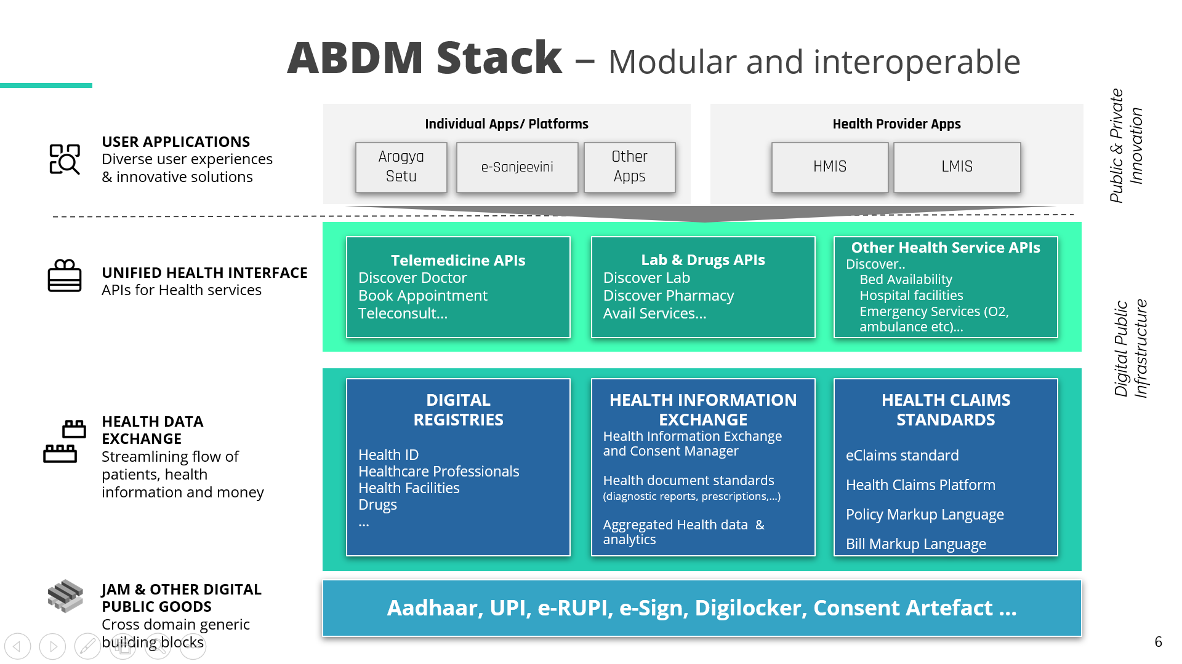Fig 1: ABDM Architecture

NDHE with the implementation of the **envisioned UHI layer** as shown in the figure 1 above, will provide choice to individuals to access both public and private health services via digital technology platforms like telemedicine applications, online sample collection apps, e-referral services and creation of digital health records. The layer is envisaged to ensure transparency, equity around service access, pricing and quality care delivery by building accountability in integration with ABDM’s health registries & verified entities participation.

# Document Scope

The “Unified Health Interface - UHI” will be released as an integral interoperability & service access layer to empower the citizens to **search and request** a required healthcare service via any of the available **End User Applications (EUAs)** integrated with ABDM ecosystem from any of the **registered health services providers** (facilities & individual health professionals etc) **and associated applications** (HMIS, e-clinic apps utilized by the health providers) for managing appointments and delivering health services to patients.

This document is intended to cover the key functionalities facilitated by **ABDM’s UHI gateway** via standardized communication protocol-based APIs & Network Registry.

The UHI gateway scope of work & the APIs that will enable the service discovery & handshaking between an EUA & HSPA for facilitating user-initiated service search via the UHI layer. The document will cover the following functionalities –

1. **Network registry – EUA & HSPA onboarding**

Network registry will be an important component of the UHI layer. It will be involved in onboarding/registration of EUA & HSPA providers who will be authorized to communicate with each other. This registry is envisioned to act as a single source of truth for all authorized network participants who have been approved and verified to ensure privacy & security of the communication and data happening within the UHI layer.

1. **Service Discovery & Handshake between EUA & HSPA**

An end user shall be able to search a required service by providing a **“search intent”** to the UHI gateway via an EUA, which in turn routs the search requests to many relevant integrated HSPAs. This function will include:

* + 1. Enable searching a healthcare service via an EUA reference application by enabling multiple advanced search criteria as detailed out under the “service discovery “section.
    2. EUA will enable service list aggregation and price comparison for services like digital consultation, physical consultations, lab sample collection, online pharmacy booking etc via the UHI gateway from multiple registered/integrated HSPAs via asynchronous calls.
    3. Enable sending a booking request to a selected HSPA from the aggregated service list and providing billing details. In turn the HSPA will share the payment link for the patient to make payment for a prepaid health service or holding the service fee amount on booking confirmation similar to credit card payments can also be explored.

**APIs used**

* **Service/product Search API** – Basic & Advanced search for EUAs to send a search intent which is routed by the gateway using the network registry and broadcasted to all registered and authorized HSPAs to get the service availability & slots.
* **Service on_search APIs** – To get response against the search intent from all the registered & authorized HSPA who has the service available. This will enable the EUA to aggregate & list the available service catalogue with the health professional and slot details for the end user to choose from to initiate a service booking.

# Definitions & Acronyms

## Definitions

|  |  |
| --- | --- |
| Keyword | Definition |
| UHI | UHI is planned to develop, implement, and operate the UHI gateway as a public good that will enable digital health services to provide services to end users in the healthcare ecosystem. |
| Health Service Provider (HSPA) | All healthcare service providers or care givers including health professionals, facilities like hospital, clinics, labs etc. are known as HSPAs. |
| End User Applications (EUA) | EUAs are patient centric applications that can be utilized by the patients to access various health services like appointment booking, digital consultation, lab sample collection booking etc. EUAs will be integrated with the UHI layer to enable service search, request and service rendering acknowledgements. |
| Consumer | A healthcare stakeholder who is requesting a healthcare service via UHI layer. |
| ABHA ID | Unique Health Identifier assigned to an individual who has registered themselves in the ABHA Registry also known as Ayushman Bharat Health Account ID. |

## 

## Acronyms

|  |  |
| --- | --- |
| Acronym | Explanation |
| ABDM | Ayushman Bharat Digital Mission |
| UHI | Unified Health Interface |
| OPD | Outpatient Department |
| API | Application Program Interface |
| HPR ID | Health professional Registry ID |
| HFR ID | Health Facility Registry ID |

# Functional Requirements Look-up Table

| Requirement ID | Category | Requirement Statement | Priority[1] |
| --- | --- | --- | --- |
| BR-001 | Network Registry | Registration of EUAs and HSPAs on UHIs Network registry as authorized network participants. | High |
| BR-002 | Service Discovery | The UHI gateway shall facilitate basic search functionality to search for services like digital consultation, physical consultations, lab sample collection, online pharmacy etc. by an end user via an EUA e.g.: Searching a service by typing the service name. | High |
| BR-003 | Service Discovery | The UHI gateway shall facilitate advance search functionality to search a service via multiple search criteria which will include –  a. Search by Health Professional’s Name/HPR ID  b. Search by Health Facility’s Name/Healthcare service provider Name//HFR ID  c. Search by healthcare services/product  d. Get services for a specific healthcare service provider via structured search intent. Enable Age, gender, experience, rating etc filters Eg: Search for a cardiologist with 5+ years of experience and who can speak Kannada  e. Search by service category name  f. Search by **Healthcare** Fulfillment Service timings  g. Search for teleconsultation services by symptom | High |
| BR-004 | Log Service Discovery | The UHI gateway should enable APIs that enables HSPA lookup via the UHI network registry when an end user performs a service search to route the search intent to multiple HSPAs. | High |
| BR-005 | Log Service Discovery | The UHI gateway should enable acknowledgement against each search call sent from an EUA which is routed via the gateway | High |
| BR-006 | Log Service Discovery | The UHI gateway should enable asynchronous communication for service discovery. | High |
| BR-007 |  | The UHI gateway should enable handshake between the EUA & HSP at the service discovery phase on selection of a HSP by the consumer. | High |
| BR-008 | Call log | The UHI gateway should maintain log of each call that is routed/passed through the gateway. | High |

# Functional Requirements Detailed Description

## Network registry requirements

UHI’s network registry will hold information about all the approved HSPAs & EUAs as subscribers who will be authorized to communicate with each other via the UHI layer for service discovery, fulfillment & post fulfillment transactions. It will be a pre-requisite step for all HSPAs & EUAs to register themselves via a UHI registration page in the network registry to ensure only ABDM authorized entity participates in the UHI communication via the standard UHI protocol. This construct is enabled to ensure secure communication is facilitated between the end user applications, gateway and the Health service provider applications. This will ensure privacy, security & authenticity of patient data and personal health information as all the EUAs and HSPAs will have to go through a sandbox like certification process to showcase security and privacy measures have been implemented by the solution providers to entail trusts amongst the end users (patients/citizens).

* A common registration page will be enabled like ABDM’s sandbox certification process to collect minimum required mandatory information about the HSPA & EUAs that the communication via the UHI platform happens only between trusted, verified entities.
* Until approved, the registered HSPA/EUA will have the status as “requested” and will be called “**registrants”**. During the review process EUA/HSPAs will show the status “Under Review”.
* Once approved the registrants will obtain “subscribed” “status and will be called **“subscribers/registered network provider”.**

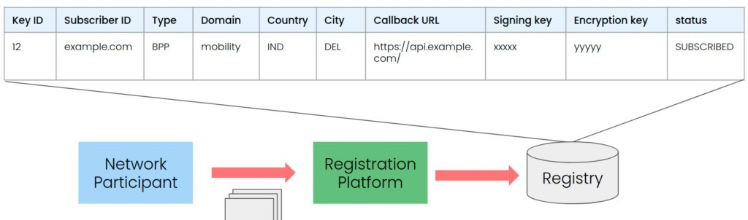

Fig: Sample registry database from [Beckn](https://developers.becknprotocol.io/docs/introduction/the-registry-infrastructure/)

**\*The gateway must authenticate the request-response sender by looking up the network registry and verify the signature, network ID & URI of the sender.**

|  |  |
| --- | --- |
| **Requirement ID** | BR-001 |
| **Requirement Statement** | Network registry shall facilitate registration of EUAs and HSPAs on UHIs Network as authorized network participants. |
| **Requirement Description** | An end user application and a Health service provider to be discoverable as part of the UHI ecosystem needs to register themselves to become a part of the UHI network registry.  The registry database will consist of minimum required mandatory fields that will be maintained in the registry database along with the status of the “Registrant” at various steps of the registration and approval process.  **Registrant** — A technology solution owned by a business or not for profit or govt entity willing to be listed in the UHI Network Registry to enable healthcare services access or delivery via the UHI layer and have requested registration. The registrant must submit relevant credentials to ABDM via the UHI Registration Page. A registrant can be an End User Application (EUA) or can be a Health Service Provider (HSPA) application.  **Registered network Partner** - after the registrant is approved by the Registration Platform, it is listed on the registry with” subscribed**”** status. From this moment on, the entity being registered in no longer a “registrant” and becomes a “subscriber” or “Registered network partner”. The subscriber status gives the entity the right to perform transactions on the network. |
| **Actor** | *EUAs, HSPAs, ABDM network provider approving board team* |
| **Steps** | 1. When a new HSPA/EUA requests registration via the front end EUA-HSPA onboarding page the HSPA/EUA’s information will be captured in the network registry with a role “Registrant”.  2. Once the HSPA/EUA registration is approved by the NHA approving body the role of the HSPA/EUA will be updated to “Subscriber/registered network provider” and only then will be authorized to integrate with the respective UHI APIs as per the role selected by the registrant at the time of registration with the registered email ID |
| **Inputs** | **Fields**   * **Unique Network Partner ID** * **Access Key** * **Type/Role- HSPA/EUA** * **Nature of entity** – Govt/Private/NGO * **Service Category** – Home Care, Diagnostics, telemedicine, Healthcare CRM, ePharmacy, Health Product retail, other * Registered user or not * Solution Provider legal Name * GSTN ID * **Registered address** – Country, State, City (LGD codes), Pin code) * **Website** * **System Admin Details** – Name, email ID, Mobile No., Password * **Call-back URL** * **Signing key** * **Encryption key** * **Status –** Registrant, Under Review, Subscribed |
| **Business Rule** | * All mandatory fields need to be provided by the registering entity * Registered entity should be authorized * The subscriber ID should be generated using the same algorithm as used for HFR and HPR IDs |
| **Expected Outcome** | Every new registrant information gets stored in the UHI network registry whenever the registrant submits the mandatory information using the UHI onboarding page. The gateway should use the network registry to route the API requests/response amongst EUA & HSPAs. |
| **Remarks** |  |

**Network Registry Workflow**

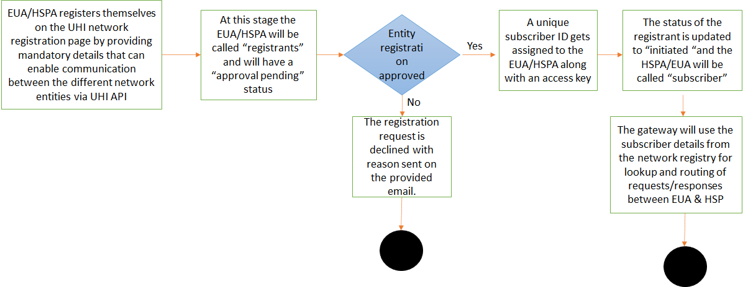

## 6.2 UHI gateway requirements

COVID 19 had brought out the need to enable digital health services to enable continuum of care when physical consultation or care delivery is not possible. To enable this UHI layer will provide a gateway and standardized open protocol-based APIs for the UHI ecosystem subscribers to communicate with each other.

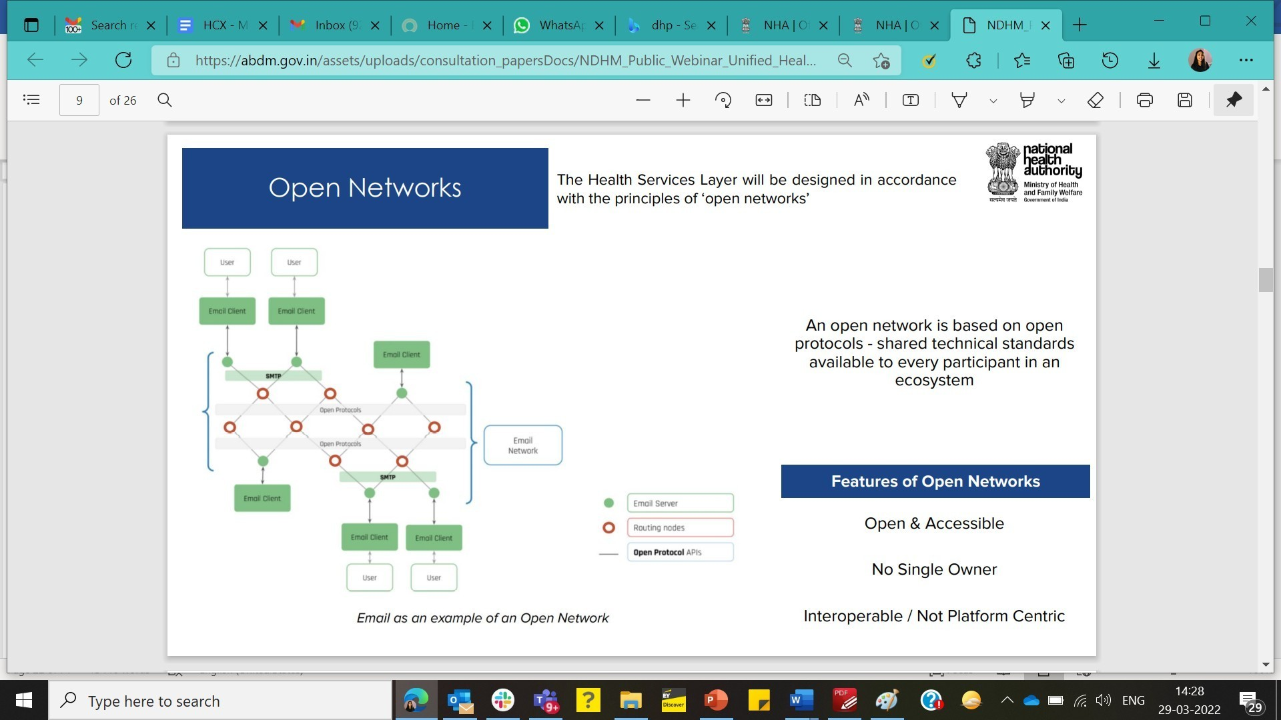

UHI gateway will be built on the similar approach as implemented for HIE-CM. The UHI gateway will enable handshake between the EUA & HSP via the service discovery phase and all other calls from Booking initiation to fulfillment will happen between the EUA & HSP directly via the public key & endpoint URIs as published in the network registry. In summary UHI gateway will be a light weight entity responsible for-

1. Service discovery and enabling handshake between a selected HSPA
2. Ensuring the interaction happens between authorized entities only via the network registry and not anyone and everyone can pass through the UHI gateway.

## Service Discovery

Service discovery in simple terms is enabling a search functionality for the citizens that they can search for any required health service which may include but not restricted to:-

1. Healthcare provider (facility) search
2. Healthcare professional (doctor) search
3. Teleconsultation services
4. Physical Consultation service
5. Lab sample collection service
6. E-pharmacy services
7. Other service appointments search

All the service discovery calls for a service search will be routed through the UHI gateway via the network registry lookup. At this stage on selection of a service from the service catalogue the gateway will enable one to one handshake between the EUA & HSPA for further transactions until the service fulfilment stage.

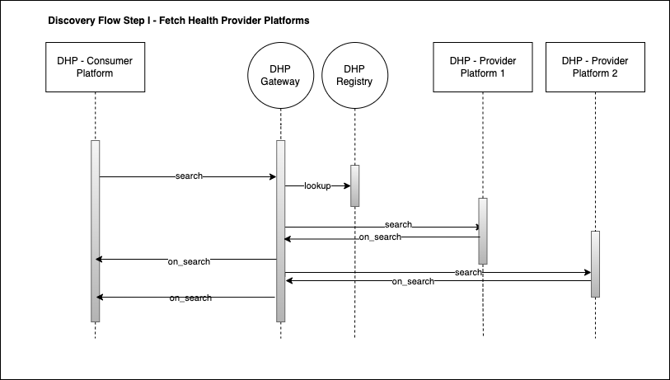

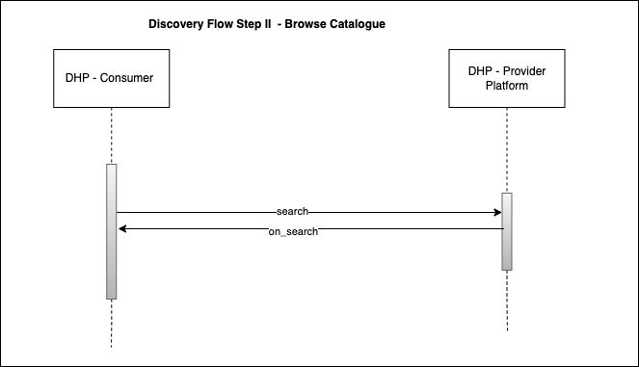

**Fig 5: Indicative flow-DHP project**

**Detailed functional requirement to enable a service discovery functionality via UHI is elaborated below-**

### Service Discovery- Basic Search – Search by healthcare service Name

|  |  |
| --- | --- |
| **Requirement ID** | BR-002 |
| **Requirement Statement** | The UHI gateway shall facilitate a basic search API to search services like digital consultation, physical consultations, lab sample collection, online pharmacy booking etc. by an end user via an EUA |
| **Requirement Description** | The UHI’s search API will enable a healthcare consumer/patient to search for a required service via **a service name search**.  The search API will capture search intent specific parameters via an EUA interface, and will send to the UHI gateway, which will then rout the searched parameters to the registered HSPAs in the network registry. The HSPAs then can publish services if available with service details like Service name, location, doctor and price list as a response via “on_search” API individually via the gateway. The multiple responses (Many-one) from multiple HSPAs will be aggregated by the EUA and will be Presented to the end user/healthcare consumer for appointment booking. |
| **Actor** | *Healthcare Consumer, EUA, UHI gateway* |
| **Steps** | A healthcare consumer registers himself on an authorized EUA registered on the UHI network.Links his/her ABHA ID with the EUA patient profile.Will search a service like digital consultation, physical consultations, lab sample collection, online pharmacy booking etc. in the search box by selecting “search service” and types “Digital consultation service” or “Walk-in consultation service”.  1. The EUA will use the “search API” to send the details to the UHI gateway. 2. UHI gateway will receive the request and searches the UHI network registry for matching service providers HSPAs. 3. The search request will be routed to relevant matching more than one HSPAs 4. On receiving the request, the HSPA will provide the service list if available as pr the search intent with additional service parameters including price to the gateway via “on search” API. 5. The gateway will rout the multiple services responses shared by multiple registered HSPAs to the requesting EUA for aggregation and presentation to the consumer to select from. 6. In addition, the HSPAs who have the searched service/product availability on receiving the search broadcast will send a negative/positive ACK message to the gateway. This will update the status against the transaction ID in the gateway-maintained log. 7. For every new search request the gateway will generate and allocate a unique transaction ID linked to the message ID and EUA network registry ID and will maintain the various statuses at various events from search to fulfillment as part of the log. |
| **Input** | * Service Category such as Radiology Investigation, Medicines, Teleconsultation, Home Care, Walk-in consultation, Ambulance * User can type free text In the search box * item (name (service name) : digital consultation) |
| **Business Rule** | * *At least one search criteria to be entered by the consumer in the search interface provided by an EUA* * *End user should have registered in the EUA app with their ABHA ID* * *EUA app to be used should be registered and authorized in the UHI network registry* * *At least one of the registered HSPA should have the searched service available* |
| **Expected Outcome** | Negative or positive Acknowledge message from gateway to EUA on successful search API call.  Negative or positive Acknowledge message from HSPAs to the gateway who have service available matching the search intent.  UHI gateway will broadcast the search intent to all the registered HSPAs in the network registry.  HSPAs with searched service availability will share the available service slots, fee, doctor details if applicable via “on_search API as response which will be routed via the gateway to the EUA.  EUA aggregates and shows service catalogue received across HSPAs in the search interface.  If no matching service is found the EUA should have configured the Time Out to show “No results found” for the requested search parameters. |
| **Remarks** |  |

### Service Discovery- Advance Search – Search by HSP name/ID (By healthcare professional, By health facility)

|  |  |
| --- | --- |
| **Requirement ID** | BR-003, BR-004, BR-005 |
| **Requirement Statement** | The UHI gateway shall facilitate advance search functionality to search for services like digital consultation, physical consultations, lab sample collection, online pharmacy booking etc. services by an end-user via an EUA. E.g.: Searching a consultations service with facility or/and doctor filter, service category etc. |
| **Requirement Description** | The search API will be developed to unable multi-parameter search for a healthcare service. The other search parameters that the search API will enable for the hackathon release includes-  **1.a. Search a service by Facility Name**  **b. Search a service by Facility ID**  **2. a. Search a service by Doctor Name**  **b. Search a service by Doctor ID/HPR ID**  **3. Search by healthcare services/product category & name**  **4. Multi-parameter search**  **5. Keyword search** E.g.: Search for a cardiologist with 5+ years of experience and who can speak Kannada |
| **Actor** | *EUAs, HSPAs, UHI gateway* |
| **Steps** | 1. A healthcare consumer registers himself on an authorized EUA registered on the UHI network. 2. Links his/her ABHA ID with the EUA patient profile. 3. Will search a healthcare service using the multiple parameter search filters enabled in the EUA user interface. 4. When consumer will select “search by facility name”, the consumer will be required to enter “**name”** of preferred facility or the **“facility’s HFR ID”** from which he/she needs to avail a physical/digital consultation from. 5. The specific search by facility with facility name details will be sent as an input via the **“search API”** to the gateway. 6. The gateway will route the search request to respective HSPA which has the services like digital consultation, physical consultations, lab sample collection, online pharmacy booking etc. listed for the asked facility name. 7. When consumer will select **“search by Doctor**”, the consumer will be required to enter name of the preferred Doctor or their associated **HPR ID** from whom he/she needs to avail a physical/digital consultation from. 8. The specific search by doctor with doctor’s name/HFR ID details will be sent as an input via the **“search API”** to the gateway. 9. The gateway will route the search request to respective HSPA which has the services like digital consultation, physical consultations, lab sample collection, online pharmacy booking etc. service listed for the asked Doctor. 10. UHI gateway will receive the request and searches the UHI network registry for matching HSPAs. 11. The search request will be routed to relevant matching HSPAs (More than one) 12. On receiving the request, the HSPA will provide the **service list with additional service parameters including “price” and “appointment slots”** to the gateway via **“on_search”** API. 13. The gateway will aggregate the multiple services responses shared by multiple registered HSPAs and route it to the requesting EUA for the consumer to select from. 14. The access code will help the EUA/HSPA to have access to the respective APIs for integration that they can participate in the identified workflow (Service Discovery- Booking- Fulfillment)   (Disclaimer: The registration process is kept minimal and simple for the hackathon release, but in future a detailed registration process linked to UHI sandbox certification would be required to integrate with the UHI production APIs) |
| **Input** | Search by service provider/health facility name   * Facility name * HFR ID * Specialty * State * Pin code * Service Name based availability * action: search * requesting EUA ID * provider (name (provider name) : Max Hospitals)   Search by healthcare professional name   * Doctor Name * HPRID * Specialty * City * Health Facility * Spoken Language * Availability * action: search * requesting EUA ID * name (Healthcare professional name): (Dr. Asthana) |
| **Business Rule** |  |
| **Expected Outcome** | *Acknowledgement of message received* |
| **Remarks** |  |

|  |  |
| --- | --- |
| **Requirement ID** | *BR-003.1a* |
| **Requirement Statement** | *The UHI gateway shall facilitate advance search functionality to search for services by* ***Facility Name*** |
| **Requirement Description** | *The search API will be developed to search for a healthcare service by the name or the HFR ID of the particular facility that the user wants to render the service from.* |
| **Actor** | *EUAs, HSPAs, UHI gateway* |
| **Steps** | 1. A healthcare consumer registers himself on an authorized EUA registered on the UHI network. 2. Links his/her ABHA ID with the EUA patient profile. 3. Will search a healthcare service using the facility name filter enabled in the EUA user interface. 4. When consumer will select “search by facility name, the consumer will be required to enter “name” of preferred facility from which he/she needs to avail a physical/digital consultation from. 5. The specific search by facility with facility name details will be sent as an input via the “search API” to the gateway. 6. The gateway will route the search request to all the HSPAs. 7. Gateway will send an automatic acknowledgement to the requesting EUA. 8. The HSPA who has the requested facility listed will share the response back via the “on_search API to the gateway. 9. Gateway will route the responses back to the EUA, where EUA will aggregate the search response with facility and services provided by the facility for the end user to choose from. |
| **Input** | *Search by service provider/health facility name*   * Facility name * HFR ID * Specialty * State * Pin code * Service Name based availability * action: search * requesting EUA ID * provider (name (provider name) : Max Hospitals) |
| **Business Rule** |  |
| **Expected Outcome** | *Acknowledgement of message received* |
| **Remarks** |  |

|  |  |
| --- | --- |
| **Requirement ID** | BR-003.1.b |
| **Requirement Statement** | The UHI gateway shall facilitate advance search functionality to search for services by **Facility ID** |
| **Requirement Description** | The search API will be developed to search for a healthcare service by the facility ID of the particular facility that the user wants to render the service from. |
| **Actor** | EUAs, HSPAs, UHI gateway |
| **Steps** | 1. A healthcare consumer registers himself on an authorized EUA registered on the UHI network. 2. Links his/her ABHA ID with the EUA patient profile. 3. Will search a healthcare service using the facility ID filter enabled in the EUA user interface. 4. When consumer will select “search by facility ID”, the consumer will be required to enter “Facility ID” of preferred facility from which he/she needs to avail a physical/digital consultation from. 5. The specific search by facility with facility ID details will be sent as an input via the “search API” to the gateway. 6. The gateway will route the search request to respective HSPA which has the services like digital consultation, physical consultations, lab sample collection, online pharmacy booking etc. listed for the asked facility ID. 7. UHI gateway will receive the request and searches the UHI network registry for matching HSPA. 8. The search request will be routed to relevant matching HSPA 9. On receiving the request, the HSPA will provide the service list with additional service parameters including “price” and “appointment slots” to the gateway via “on_search” API. 10. The gateway will aggregate the multiple services responses shared by multiple registered HSPA and route it to the requesting EUA for the consumer to select from. 11. The access code will help the EUA/HSPA to have access to the respective APIs for integration that they can participate in the identified workflow (Service Discovery- Booking- Fulfillment) |
| **Input** | Search by service provider/health facility ID   * Facility name * HFR ID * Specialty * State * Pin code * Service Name based availability * action: search * requesting EUA ID * provider (ID (provider ID): 152836902824) |
| **Business Rule** |  |
| **Expected Outcome** | Acknowledgement of message received |
| **Remarks** |  |
|  |  |
| **Requirement ID** | BR-003.2.a |
| **Requirement Statement** | *The UHI gateway shall facilitate advance search functionality to search for services by* ***Doctor Name*** |
| **Requirement Description** | *The search API will be developed to search for a healthcare service by the name of the particular doctor that the user wants to render the service from.* |
| **Actor** | *EUAs, HSPAs, UHI gateway* |
| **Steps** | 1. *A healthcare consumer registers himself on an authorized EUA registered on the UHI network.* 2. *Links his/her ABHA ID with the EUA patient profile.* 3. *Will search a healthcare service using the doctor’s name filter enabled in the EUA user interface.* 4. When consumer will select **“search by Doctor name**”, the consumer will be required to enter name of the preferred Doctor from whom he/she needs to avail a physical/digital consultation from. 5. The specific search by doctor with doctor’s name/HFR ID details will be sent as an input via the **“search API”** to the gateway. 6. The gateway will route the search request to respective HSPA which has the services like digital consultation, physical consultations, lab sample collection, online pharmacy booking etc. service listed for the asked Doctor. 7. *UHI gateway will receive the request and searches the UHI network registry for matching HSPAs.* 8. *The search request will be routed to relevant matching HSPAs (More than one)* 9. *On receiving the request, the HSPA will provide the service list with additional service parameters including “price” and “appointment slots” to the gateway via “on_search” API.* 10. *The gateway will aggregate the multiple services responses shared by multiple registered HSPAs and route it to the requesting EUA for the consumer to select from.* 11. *The access code will help the EUA/HSPA to have access to the respective APIs for integration that they can participate in the identified workflow (Service Discovery- Booking- Fulfillment)* |
| **Input** | *Search by service provider/health facility name*   |  | | --- | | * Doctor Name * HPRID * Specialty * City * Health Facility * Spoken Language * Availability * action: search * requesting EUA ID * name (Healthcare professional name): (Dr. Asthana) | |
| **Business Rule** |  |
| **Expected Outcome** | *Acknowledgement of message received* |
| **Remarks** |  |
|  |  |
| **Requirement ID** | BR-003.2.b |
| **Requirement Statement** | *The UHI layer shall facilitate advance search APIs to search for services by* ***Health Professional ID*** |
| **Requirement Description** | *The search API will be developed to search for a healthcare service by the Health professional ID of the particular doctor that the user wants to render the service from.* |
| **Actor** | *EUAs, HSPAs, UHI gateway* |
| **Steps** | 1. *A healthcare consumer registers himself on an authorized EUA registered on the UHI network.* 2. *Links his/her ABHA ID with the EUA patient profile.* 3. *Will search a healthcare service using the doctor ID filter enabled in the EUA user interface.* 4. When consumer will select **“search by Doctor ID**”, the consumer will be required to enter HPRID of the preferred Doctor from whom he/she needs to avail a physical/digital consultation from. 5. The specific search by doctor with doctor’s ID details will be sent as an input via the **“search API”** to the gateway. 6. The gateway will route the search request to respective HSPA which has the services like digital consultation, physical consultations, lab sample collection, online pharmacy booking etc. service listed for the asked Doctor. 7. UHI gateway will receive the request and searches the UHI network registry for matching HSPA. 8. The search request will be routed to relevant matching HSPA 9. On receiving the request, the HSPA will provide the service list with additional service parameters including “price” and “appointment slots” to the gateway via “on_search” API. 10. The gateway will aggregate the multiple services responses shared by registered HSPA and route it to the requesting EUA for the consumer to select from. 11. The access code will help the EUA/HSPA to have access to the respective APIs for integration that they can participate in the identified workflow (Service Discovery- Booking- Fulfillment) |
| **Input** | Search by health professional ID   |  | | --- | | 1. Doctor Name 2. HPRID 3. Specialty 4. City 5. Health Facility 6. Spoken Language 7. Availability 8. action: search 9. requesting EUA ID 10. cred: uhiId:98479873843985 | |
| **Business Rule** |  |
| **Expected Outcome** | *Acknowledgement of message received* |
| **Remarks** |  |
|  |  |
| **Requirement ID** | BR-003.3 |
| **Requirement Statement** | *The UHI layer shall facilitate advance search APIs to search for services by* ***Healthcare Services Category Name*** |
| **Requirement Description** | *The search API will be developed to search for a healthcare service by the Healthcare services category name of the particular service that the user wants to avail.* |
| **Actor** | *EUAs, HSPAs, UHI gateway* |
| **Steps** | 1. *A healthcare consumer registers himself on an authorized EUA registered on the UHI network.* 2. *Links his/her ABHA ID with the EUA patient profile.* 3. *Will search a healthcare service using the doctor ID filter enabled in the EUA user interface.* 4. When consumer will select **“search by Healthcare service category name**”, the consumer will be required to enter name of the preferred Healthcare service which he/she needs to avail 5. The specific search by service name with service details will be sent as an input via the **“search API”** to the gateway. 6. The gateway will route the search request to respective HSPAs which has the services like digital consultation, physical consultations, lab sample collection, online pharmacy booking etc. service listed for the asked intended service. 7. *UHI gateway will receive the request and searches the UHI network registry for matching HSPAs.* 8. *The search request will be routed to relevant matching HSPAs* 9. *On receiving the request, the HSPA will provide the service list with additional service parameters including “price” and “appointment slots” to the gateway via “on_search” API.* 10. *The gateway will aggregate the multiple services responses shared by registered HSPA and route it to the requesting EUA for the consumer to select from.* 11. *The access code will help the EUA/HSPA to have access to the respective APIs for integration that they can participate in the identified workflow (Service Discovery- Booking- Fulfillment)* |
| **Input** | *Search by healthcare service category name*   |  | | --- | | * Service Category such as Radiology Investigations, Lab Investigation, Medicines, Teleconsultation, * name: dr. asthana | |
| **Business Rule** |  |
| **Expected Outcome** | *Acknowledgement of message received* |
| **Remarks** |  |
|  |  |
| **Requirement ID** | BR-003.4 |
| **Requirement Statement** | *The UHI layer shall facilitate advance search APIs to search for tele-consultation services by symptom* |
| **Requirement Description** | *The search API will be developed to search for tele- consultation service by the symptoms observed by the user.* |
| **Actor** | *EUAs, HSPAs, UHI gateway* |
| **Steps** | 1. *A healthcare consumer registers himself on an authorized EUA registered on the UHI network.* 2. *Links his/her ABHA ID with the EUA patient profile.* 3. *Will search a teleconsultation service by entering symptom filter enabled in the EUA user interface.* 4. When consumer will select **“search by symptom**”, the consumer will be required to enter symptoms observed by the consumer 5. The specific search by symptoms with service details will be sent as an input via the **“search API”** to the gateway. 6. The gateway will route the search request to respective HSPAs which has the teleconsultation services listed for the observed symptoms. 7. *UHI gateway will receive the request and searches the UHI network registry for matching HSPAs.* 8. *The search request will be routed to relevant matching HSPAs* 9. *On receiving the request, the HSPA will provide the service list with additional service parameters including “price” and “appointment slots” to the gateway via “on_search” API.* 10. *The gateway will aggregate the multiple services responses shared by registered HSPA and route it to the requesting EUA for the consumer to select from.* 11. *The access code will help the EUA/HSPA to have access to the respective APIs for integration that they can participate in the identified workflow (Service Discovery- Booking- Fulfillment)* |
| **Input** | *Search for teleconsultation by symptoms*   |  |  |  | | --- | --- | --- | | Keyword search- User can type free text in the search box e.g., fever 101C, cough, cold, diarrhea, etc.  item (name (service name): fever   |  |  | | --- | --- | |  |  | | |
| **Business Rule** |  |
| **Expected Outcome** | *Acknowledgement of message received* |
| **Remarks** |  |

|  |  |
| --- | --- |
| **Requirement ID** | BR-006, BR-007 |
| **Requirement Statement** | The UHI gateway should enable asynchronous communication for service discovery supported by automated acknowledgement by the gateway on receiving a API call wherein the EUA aggregates the responses received into service catalogue. |
| **Requirement Description** | The UHI layer facilitates an “on_search” API which is response API which is responsible for receiving service catalogues from multiple HSPs against a search intent. The gateway then routes the received response to EUA. The service list is aggregated by the EUA and published to the consumer. |
| **Actor** | *EUAs, HSPAs, UHI gateway* |
| **Steps** | 1. When a consumer searches for a service-by-service name, doctor or by facility via the “search API”, the search intent is routed by the UHI gateway to the HSPAs via the information available in the network registry.  2. The HSPAs will provide service details like service name, doctor details, available slot, fee etc if the searched service is available via the “on_search API” to the gateway individually asynchronously.  3. The UHI gateway then routes the received response from each HSPA to the requesting EUA.  3. The EUA aggregates the service details across the multiple relevant HSPAs and shares the aggregated service catalogue back to the consumer to select the service that suits his/her selection parameters.  4. On selection of a slot/service the UHI gateway enables on to one communication between the HSPA & EUA |
| **Inputs** | Catalog of Doctors with their availability schedule for DIGITAL OPD Fulfillment:   * EUA network registry ID * EUA’s URI * Unique Transaction ID * Time Date Stamp * Search Category (TBD) * ACK response * HSPA response transaction ID sent via asynchronous communication with time: date stamp * Status: Search response received |
| **Business Rule** | * *All mandatory fields need to be provided by the registering entity* * *The subscriber ID should be generated using the same algorithm as used for HFR and HPR IDs* |
| **Expected Outcome** | *1. Every new registrant information gets stored in the UHI network registry whenever the registrant submits the mandatory information using the UHI onboarding page*  *2. Acknowledgement received by EUA*  *3. On selection a one-to-one communication is established by the UHI gateway between the EUA & HSPA* |
| **Remarks** |  |

|  |  |
| --- | --- |
| **Requirement ID** | BR-008 |
| **Requirement Statement** | The UHI gateway should maintain log of each call that is routed/passed through the gateway. |
| **Requirement Description** | Since the service discovery calls are asynchronous calls, the UHI gateway must maintain a call log to monitor the participating network partner’s performance, response time and active/inactive status.  The log will also help in aiding any dispute/grievance support. |
| **Actor** | *EUAs, HSPAs, UHI gateway* |
| **Steps** | 1. The UHI gateway maintains a log of calls received from an EUA against the EUA ID with search intent details and time date stamp linked to a request ID.  2. For every new unique search the gateway should allocate a unique request ID, against which the entire transaction from discovery to fulfillment can be tracked.  3. On receiving a response from multiple HSPAs every response ID should be recorded against the request ID linked to the HSPA ID of the responding HSPA.  4. The log should maintain the status against the request ID from discovery to fulfillment as requested, response provided, service selected, initiated, service booked, service confirmed, service rendered.  5. The status should automatically update in the log against a unique request ID where the service discovery communication was initiated.  6. Time to time HSPA should have mechanism to update the status of the service against the request ID post the service discovery, since its outside the purview of gateway but the status information is required to solve any grievance, dispute or monitoring the performance of the HSPA. |
| **Inputs** | The log should store the following data elements:   * EUA network registry ID * EUA’s URI * Unique Transaction ID * TimeDate Stamp * Search Category (TBD) * Call received -Time:Date * ACK response * HSPA response transaction ID sent via asynchronous communication with time:date stamp * Request Status * Call status: failed, success |
| **Business Rule** | *The log gets created with every API call* |
| **Expected Outcome** | *Gateway maintains the API call log and response time for each unique discovery request* |
| **Remarks** |  |

# Assumptions

|  |  |  |  |
| --- | --- | --- | --- |
| **Sr. No.** | **Assumptions** | **Status** | **Comments** |
| 1. | The UHI layer will enable services like digital consultation, physical consultations, lab sample collection, online pharmacy booking etc. | Confirmed |  |
| 2. | The payment part which includes requesting quote, booking initiation, creating a service order or actual payment via an EUA is kept out of scope | Confirmed |  |
| 3. | A single page application with Getx and DIO library - single page application should be able to send request to DHP and get the result | Confirmed |  |
| 4. | Formatted results from the single page application should be placed in one of the flutter widgets | Confirmed |  |
| 5. | Mock JSON file to be created at Mock server | Confirmed |  |
| 6. | Their corresponding service is configured in DHP so that Flutter Apps can consume | Confirmed |  |
| 7. | A spring boot application will be built with a rest controller having three similar services exposed for the hackathon.  These three services /HSPA-1 , /HSPA-2, /HSPA-3 return three json files and the result is aggregated at the DHP side | Confirmed |  |
| 8. | A jar file will be set for the line item above to expose three endpoints | Confirmed |  |

# Issues

|  |  |  |  |
| --- | --- | --- | --- |
| **Sr. No.** | **Issues** | **Status** | **Comments** |
|  | None |  |  |

# Dependencies

|  |  |  |  |
| --- | --- | --- | --- |
| **Sr. No.** | **Dependencies** | **Status** | **Comments** |
|  | For sizing requirement of the UHI hackathon, the CSP provider will have to support the scale of expected trabsactions |  |  |

# Documents

| **S No** | **Document Name** | **Source** | **Remarks** |
| --- | --- | --- | --- |
| **1.** | **UHI consultation paper** | [Synopsis_Consultation_Paper_on_UHI.pdf (abdm.gov.in)](https://abdm.gov.in/assets/uploads/consultation_papersDocs/Synopsis_Consultation_Paper_on_UHI.pdf) |  |
| **2.** | **UHI explained in layman language** | [UHI Overview_IEC_CBMaterialUHI.pdf (abdm.gov.in)](https://abdm.gov.in/assets/uploads/consultation_papersDocs/UHI%20Overview_IEC_CBMaterialUHI.pdf) |  |
| **3.** | **DHP documentation** | [Home · dhp-project/DHP-Specs Wiki (github.com)](https://github.com/dhp-project/DHP-Specs/wiki) |  |
| **4.** | **DHP API specifications** | [Getting Started: Enabling Digital Consultation using DHP · dhp-project/DHP-Specs Wiki (github.com)](https://github.com/dhp-project/DHP-Specs/wiki/Getting-Started:-Enabling-Digital-Consultation-using-DHP#selection-of-the-doctor-to-receive-consultation-price) |  |
| **5.** | **Reference Beckn API specifications (YAML)** | [protocol-specifications/core.yaml at master · beckn/protocol-specifications (github.com)](https://github.com/beckn/protocol-specifications/blob/master/core/v0/api/core.yaml) |  |
| **3.** | **Beckn Protocol Page** | [Home - Beckn Protocol](https://becknprotocol.io/) |  |

# Discussions, Meetings

| **S No** | **Date** | **Participants** | **Agenda** |
| --- | --- | --- | --- |
| **1.** | **23.02.2022** | **Vivek Eluri** | **Initiate discussions on UHI** |
| **2.** | **25.02.2022** | **Anand Ravindran, Faroque Ahamed, Sidharth Yadav, Vivek Eluri** | **Expectations setting for UHI functional requirements for Hackathon** |
| **3.** | **26.02.2022** | **Anand Ravindran, Faroque Ahamed, Sidharth Yadav, Vivek Eluri** | **UHI workflow discussion** |
| **4.** | **4.03.2022** | **Amod Joshi, Anand Ravindran, Deepak Kumar, Faroque Ahamed, Sidharth Yadav, Vivek Eluri** | **Daily UHI standup** |
| **5.** | **5.03.2022** | **Amod Joshi, Anand Ravindran, Deepak Kumar, Faroque Ahamed, Sidharth Yadav, Vivek Eluri** | **Daily UHI standup** |
| **6.** | **6.03.2022** | **Amod Joshi, Anand Ravindran, Deepak Kumar, Faroque Ahamed, Sidharth Yadav, Vivek Eluri** | **Daily UHI standup** |
| **7.** | **7.03.2022** | **Amod Joshi, Anand Ravindran, Deepak Kumar, Faroque Ahamed, Sidharth Yadav, Vivek Eluri** | **Daily UHI standup** |
| **8.** | **8.03.2022** | **Amod Joshi, Anand Ravindran, Deepak Kumar, Faroque Ahamed, Sidharth Yadav, Vivek Eluri** | **Daily UHI standup** |
| **9.** | **9.03.2022** | **Amod Joshi, Anand Ravindran, Deepak Kumar, Faroque Ahamed, Sidharth Yadav, Vivek Eluri** | **Daily UHI standup** |
| **10** | **10.03.2022** | **Amod Joshi, Anand Ravindran, Deepak Kumar, Vivek Eluri** | **Daily UHI standup** |

# Document History

| **Version** | **Date** | **Author** | **Reviewed by** | **Approved by** | **Nature of changes** |
| --- | --- | --- | --- | --- | --- |
| **Hackathon Version 1.0** | **11.03.2022** | **Priyanka Yadav** |  |  |  |
|  |  |  |  |  |  |

ACEO review-11th March 2022

1. Search for service- presentation to R S Sharma sir- tomorrow afternoon preferred – approach & timeline-what are we going to present

2. Policy call pending – Wen a doctor is part of a registered facility but the doctor is not part of the HPR- How will this be handled- The slot will be shown against a facility and not the doctor, Facility can choose to allocate the blocked slot to any of their registered doctor- Policy call finalization pending

3. Full-fledged HSPA & EUA will be developed- Kiran G sir- Can we use Arogya Setu be used as EUA by developing search and other features than creating an EUA from scratch

E-sanjeevani to be used as an HSPA.

1. Priority: High, Medium or Low